Welcome to Kindergarten Open House
Thursday, August 18, 2022
6:30pm – 8:00pm
Agenda

6:30 Families to Gym (students and parents)

6:40 – 6:55 Welcome, Introduction of Kindergarten Teachers and PowerPoint Presentation.

6:55-7:10 PTA Welcome and Presentation

7:15 – 7:30 Classroom Visits (scavenger hunt & questions)

7:30 – 8:00 Building Tours for families while children enjoy a Read Aloud in their classroom.
Dr. O’Mara will take Mrs. Beck’s Class.
Mr. Galbreath will take Mrs. Soukup’s Class.
Mrs. Worsdall will take Mrs. Juhasz’s Class.

8:00 Tour ends.
Dr. O’Mara will bring Mrs. Beck’s class to the library to end open house.
Mr. Galbreath will bring Mrs. Soukup’s Class to the gym to end open house.
Mrs. Worsdall will bring Mrs. Juhasz’s class to the cafeteria to end open house.

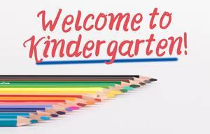

Thank you for joining us this evening! Here’s to an excellent 2022-2023 school year!

