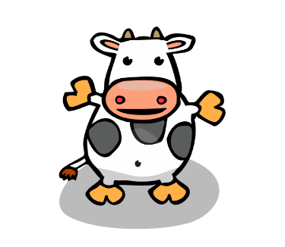
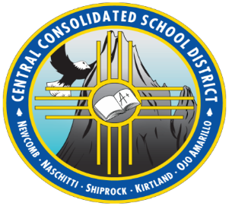

Open for Incoming Kindergarten and First Grade for SY 21-22
NAVAJO DUAL LANGUAGE IMMERSION
@ Naschitti Elem.
Your child does not have to be proficient in Navajo
Naschitti & Newcomb area CCSD STUDENTS
Would you like your child to develop the Navajo Language?
Increase their Navajo cultural identity?
Grow in Navajo Speaking, Reading & Writing?

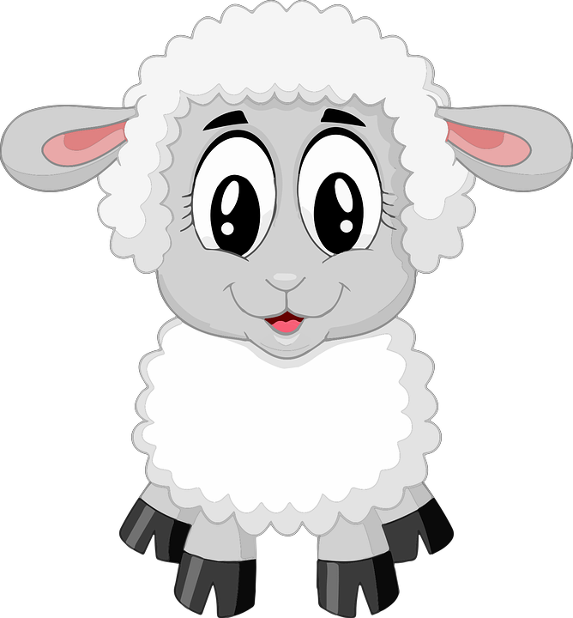
CONTACT INFORMATION:
Intercultural & Community Outreach @ (505) 368-5175
Shiprock, NM

