15181 State Route 58
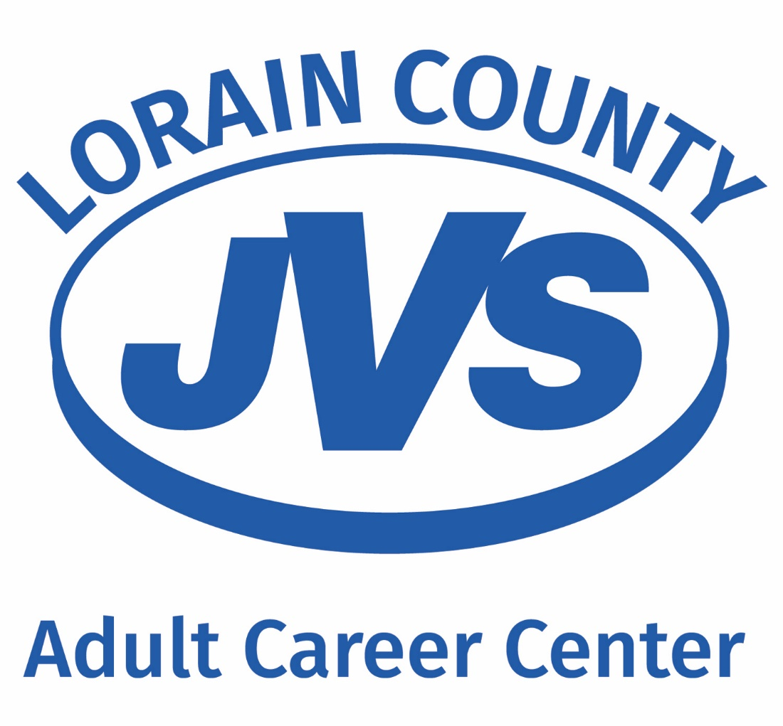
Oberlin, OH 44074
440.774.1051 Ext. 22254
Fax: 440.776.2070
www.lcjvs.com

Welcome to the Lorain County JVS Adult Career Center!
Thank you for your interest in a LCJVS Career Development Program. This information packet is designed to answer many of the questions you may have regarding federal financial assistance.

WHAT IS FEDERAL STUDENT AID?
Federal Student Aid is assistance for students to help cover school expenses including tuition and fees. At LCJVS Adult Career Center, students who enroll in full-time (600 hours or more) programs may apply for federal financial aid. Financial Aid is administered by the U.S. Department of Education and is based on financial need. The two main types of federal financial aid are the Pell Grant and William D. Ford Federal Direct Loans:
  - Pell Grant – The Federal Pell Grant is available to those who qualify. It is a grant that does not need to be repaid.
  - Direct Loans – Direct Loans can be borrowed to assist with school costs, but they MUST be paid back after you complete school, withdraw or drop below half-time enrollment.

PLEASE NOTE: You must be making Satisfactory Academic Progress (SAP) as stated in the student handbook in order to maintain financial aid eligibility. Satisfactory academic progress requires a 77% grade average and a 90% attendance rate (pace of completion) to ensure completion within the maximum timeframe. Students must maintain pace that will ensure completion within 111% of the published length of the program. SAP is monitored throughout the program.

WHAT IS THE FAFSA?
The Free Application for Federal Student Aid (FAFSA) is the form used to apply for federal financial aid. This form can be completed online at www.fafsa.ed.gov . LCJVS’s school code to be entered on the FAFSA is 026038.
- You must use data from your 2021 tax return when completing the 2023-2024 FAFSA. Utilize the IRS Data Retrieval Tool to have you and/or parent tax information uploaded easily.
- If the Data Retrieval Tool doesn’t work for you and/or parent:
- Access the tax software product you used to prepare and file your 2021 return. You must be able to access your account to download/print a copy.
- Contact the tax prepare/provider who filed your 2021 return if you used a tax professional.
- Download your tax transcript (a summary) at Get Transcript Online. Review the rigorous identity authentication requirements for Secure Access before attempting to register.
- Use Get Transcript by Mail and a transcript will be mailed to the address on your return within 5 to 10 days.
- Call the automated line at 800-908-9946 to order a transcript by mail.
If you filed an amended tax return, Form 1040X, you should use the adjusted gross income and earned income listed on your revised tax return (source: www.irs.gov).

Tips when you complete the FAFSA:
- Remember that it is a FREE website. If you are asked to pay a fee, then you may be at the wrong website. Do not pay a fee to complete your FAFSA! The correct website is www.fafsa.ed.gov.
- Create your FSA (Federal Student Aid) ID online at https://fsaid.ed.gov. This will allow you to electronically sign your FAFSA, and it may be used later in applying for a Direct Loan.
- Items needed to complete the FAFSA may include: social security number, driver’s license, federal tax returns, bank & investment statements, and benefit statements from ODJFS or SSA, if applicable.

Pell Grant
HOW MUCH PELL GRANT CAN I RECEIVE?
By completing the FAFSA, you automatically apply for Pell Grant eligibility. The Pell Grant award amount is determined by the U.S. Department of Education. The maximum Pell Grant award (for a 900 clock hour program) that an individual may receive for the 2023-2024 is $7,395; however your individual need and the number of clock hours of the program that you select will determine your specific award. Students receiving the Pell Grant will need to make payment arrangements for the tuition balance prior to registering for a program as the Pell Grant doesn’t cover the cost of any program 100%.

William D. Ford Federal Direct Loan Program
WHAT DO I NEED TO KNOW ABOUT DIRECT LOANS?
The Direct Loan program (Subsidized and Unsubsidized) is administered by the U.S. Department of Education to assist students with educational expenses. Loans are issued after certification by the LCJVS Adult Career Center.

WHAT IS THE DIFFERENCE BETWEEN SUBSIDIZED AND UNSUBSIDIZED LOANS?
A Subsidized Loan is a need-based loan on which the government pays the accumulating interest while you are in school and during the six month grace period after graduation.

An Unsubsidized Loan is not based on need, and the student is responsible for paying the interest that accumulates from the time of disbursement including the grace period after graduation. You may defer interest payments until your repayment period and have the accrued interest capitalized or added to your principal balance at that time. Please note that this increases your total loan amount, so it is best to pay the interest before it is capitalized.

WHAT IS THE INTEREST RATE ON A FEDERAL DIRECT LOAN?
Congress has passed and the President has signed the Bipartisan Student Loan Certainty Act of 2013, which ties federal student loan interest rates to financial markets. Under this Act, interest rates will be determined each June for new loans being made for the upcoming award year, which runs from July 1 to the following June 30. Each loan will have a fixed interest rate for the life of the loan.

ORIGINATION FEES:
Students will be charged a loan fee (also called an origination fee) on Direct Subsidized and Direct Unsubsidized Loans. The loan fee is an expense of borrowing one of these loans. The loan fee is a percentage of the amount of each loan the borrower receives, and is subtracted proportionately from each loan disbursement.

2 REQUIRED STEPS TO APPLY FOR STUDENT LOAN(S)
You must Log into https://studentaid.gov/h/complete-aid-process. You will need your FSA ID & password (from filling out the FAFSA) to complete 2 tasks. These must be completed prior to your financial aid appointment.
- Complete Entrance Counseling
- Complete a Master Promissory Note (MPN)

WHAT IS A MASTER PROMISSORY NOTE?
The master promissory note (MPN) serves as the legal document between the borrower and the lender. https://studentaid.gov/mpn/subunsub/landing
WHAT IS ENTRANCE COUNSELING?
Entrance counseling is an opportunity for student loan borrowers to learn about the rights and responsibilities associated with the Direct Student Loan program. Entrance counseling is a requirement in order to complete the student loan process. https://studentaid.gov/app/counselingInstructions.action?counselingType=entrance

