LORAIN COUNTY ALUMNI
EDUCATIONAL FOUNDATION SCHOLARSHIP
APPLICATION

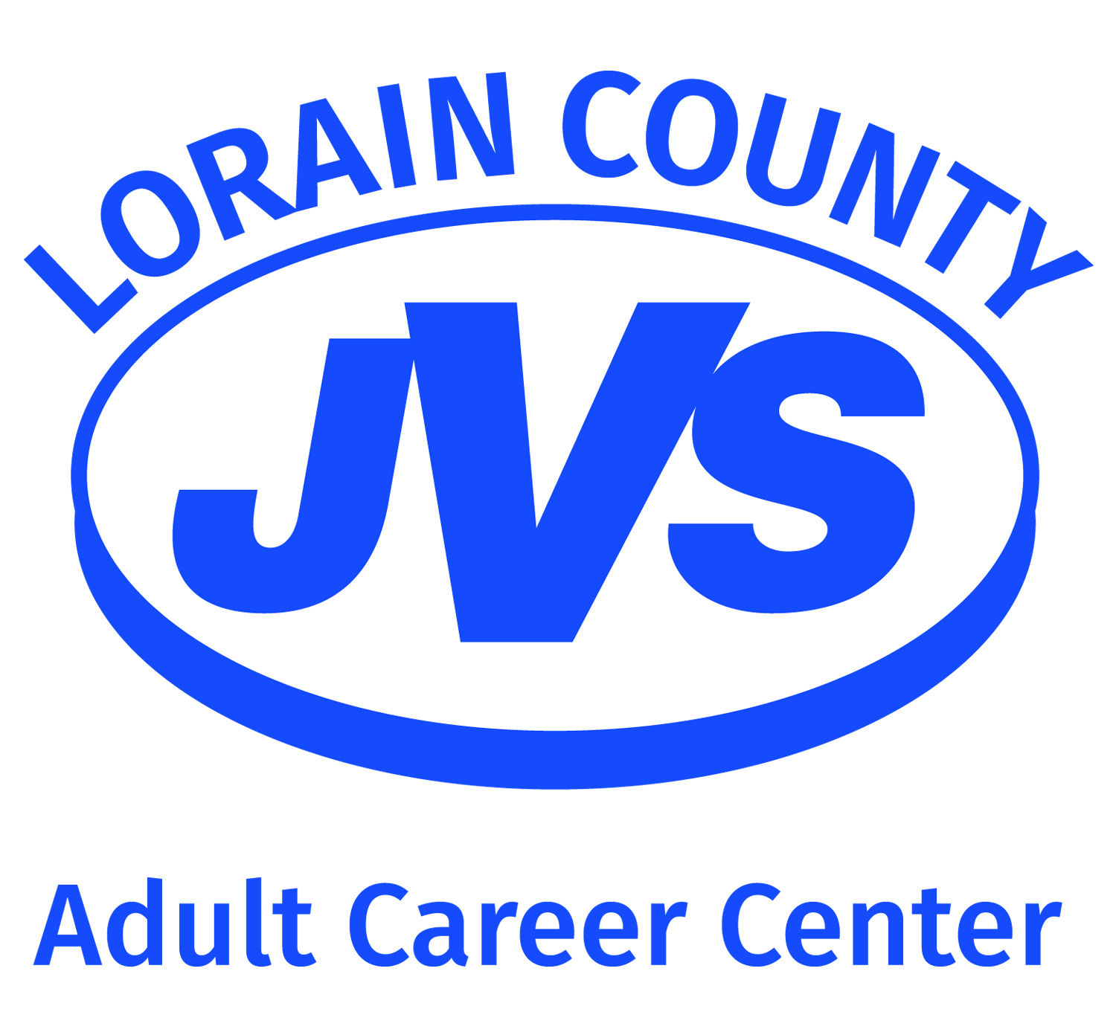

The Lorain County JVS Adult Career Center and Educational Foundation is proud to be able provide Scholarship opportunities to selected students looking to attend a 100+ Hour Career Development Program through our Adult Career Center.
The JVS Alumni Educational Foundation Scholarship is available to selected student(s) who:
- Is looking to attend an Adult Career Center program that is 100 hours or more.
- Is a LCJVS High School grad and/or Adult Career Center Career Development Program Completer. You must provide a copy of transcript showing attendance at LCJVS along with diploma from home high school and/or Certificate of Completion from an Adult Career Center Career Development Program.
- Completes the application information/questions below. If more space is needed, please feel free to attach additional paper.
- Obtains a non-related professional reference.
- Reference letter and application must be turned in prior to enrolling in class.
Please Note:
- If tuition for the program is less than $2,000k, the scholarship will be for $500.00. If tuition for the program is more than $2,000k, the scholarship will be for $1,000k.
- Scholarship recipients must attend at least 60% of the program before scholarship money will be credited towards tuition.
- Completion of the application is not a guarantee of scholarship. The Adult Career Center staff will review the application and you will be contacted when award recipients have been determined.

Student Name: Career Development Program:
Please provide a statement as to why you are deserving of a scholarship (provide insight in regards to your life situation, financial situation, dedication to being a student, etc.). Also, please provide a statement as to your future plans and how completion of the program fits in:

Student Signature: Date:
9/2/2020

Reference Letter

The Lorain County JVS Adult Career Center and Educational Foundation is proud to be able provide Scholarship opportunities to selected students looking to attend a 100+ Hour Career Development Program through our Adult Career Center.
The JVS Alumni Educational Foundation Scholarship is available to selected student(s) who:
- Is looking to attend an Adult Career Center program that is 100 hours or more.
- Is a LCJVS High School grad and/or Adult Career Center Career Development Program Completer. You must provide a copy of transcript showing attendance at LCJVS along with diploma from home high school and/or Certificate of Completion from an Adult Career Center Career Development Program.
- Completes the application information/questions below. If more space is needed, please feel free to attach additional paper.
- Obtains a non-related professional reference.
- Reference letter and application must be turned in prior to enrolling in class.
Please Note:
- If tuition for the program is less than $2,000k, the scholarship will be for $500.00. If tuition for the program is more than $2,000k, the scholarship will be for $1,000k.
- Scholarship recipients must attend at least 60% of the program before scholarship money will be credited towards tuition.
- Completion of the application is not a guarantee of scholarship. The Adult Career Center staff will review the application and you will be contacted when award recipients have been determined.

Reference Name: Student Name:
Please provide a statement as to why you believe the student is deserving of a scholarship.

Reference Signature: Date:
9/2/2020

