Monday | Tuesday | Wednesday | Thursday | Friday
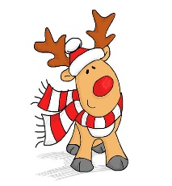  This Photo by Unknown Author is licensed under CC BY | Canned Food Drive  Begins!  We will be collecting any canned or dried goods for the Lion’s Club.  Examples: canned items, crackers, pasta, any boxed items  DUE BY: 12/13  All donations are appreciated! | 4  Ho! Ho! Ho!  Holiday Hat Day!  Wear a holiday hat, headband, or get creative with your hair! | 5  Deck the Halls with Boughs of Holly!  We will be making ornaments at school to give our hallways some holiday pizazz! | 6  Santa Claus is Coming to Town!  Wear RED and GREEN today to show your spirit!  This Photo by Unknown Author is licensed under CC BY-NC
9  Country Christmas!  Wear your favorite country outfit with boots, denim, hats, and buckles!  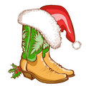 | 10  Let it Snow! Let it Snow! Let It Snow!  Wear all the white you can today. It will be “snow” much fun! | 11  Quiet as a Mouse Slipper Day!  Shhh! Wear your favorite holiday slippers or socks today!  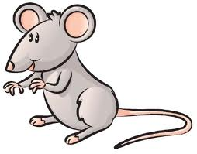 | 12  Candy Cane Day!  Wear red and white. Add some stripes too!  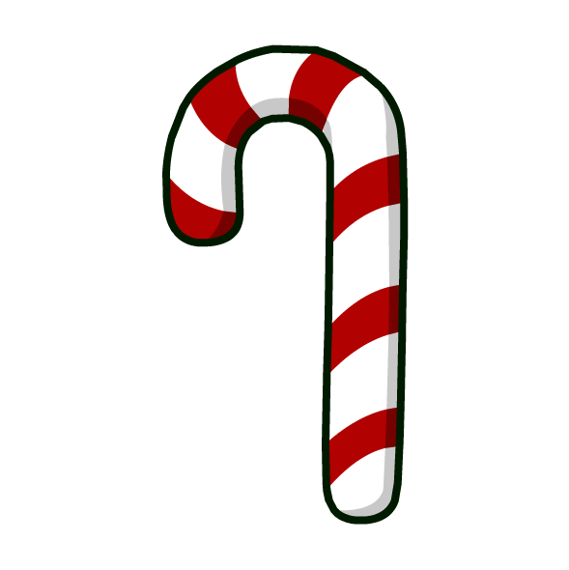 | 13  Shimmer and Shine with Kindness!  Wear some sparkles and look your best as we spread a little kindness wherever we go!  First Grade Christmas Music Show
16  Long Winter’s Nap!  Wear your favorite comfy  pajamas. It is sure to be a cozy day!  Puppet Show  We will be enjoying a puppet show today! | 17  Jingle All the Way!  Today we will be jingling our way all the way to the Green in town with our best singing voices! Bring some bells. Come and join us!  K: 9:15 – 9:30  2nd: 9:30 – 9:45  1st: 9:45 – 10:00 | 18  Grinch Day!  Wear all the GREEN you can find OR dress up as your favorite Who Character! | 19  Holiday Sweater Day!  Beautiful, ugly, or one of Grandpa’s…you choose! Wear a sweater!  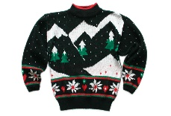  This Photo by Unknown Author is licensed under CC BY-SA | 20  No School
12 Days of Holiday Fun

