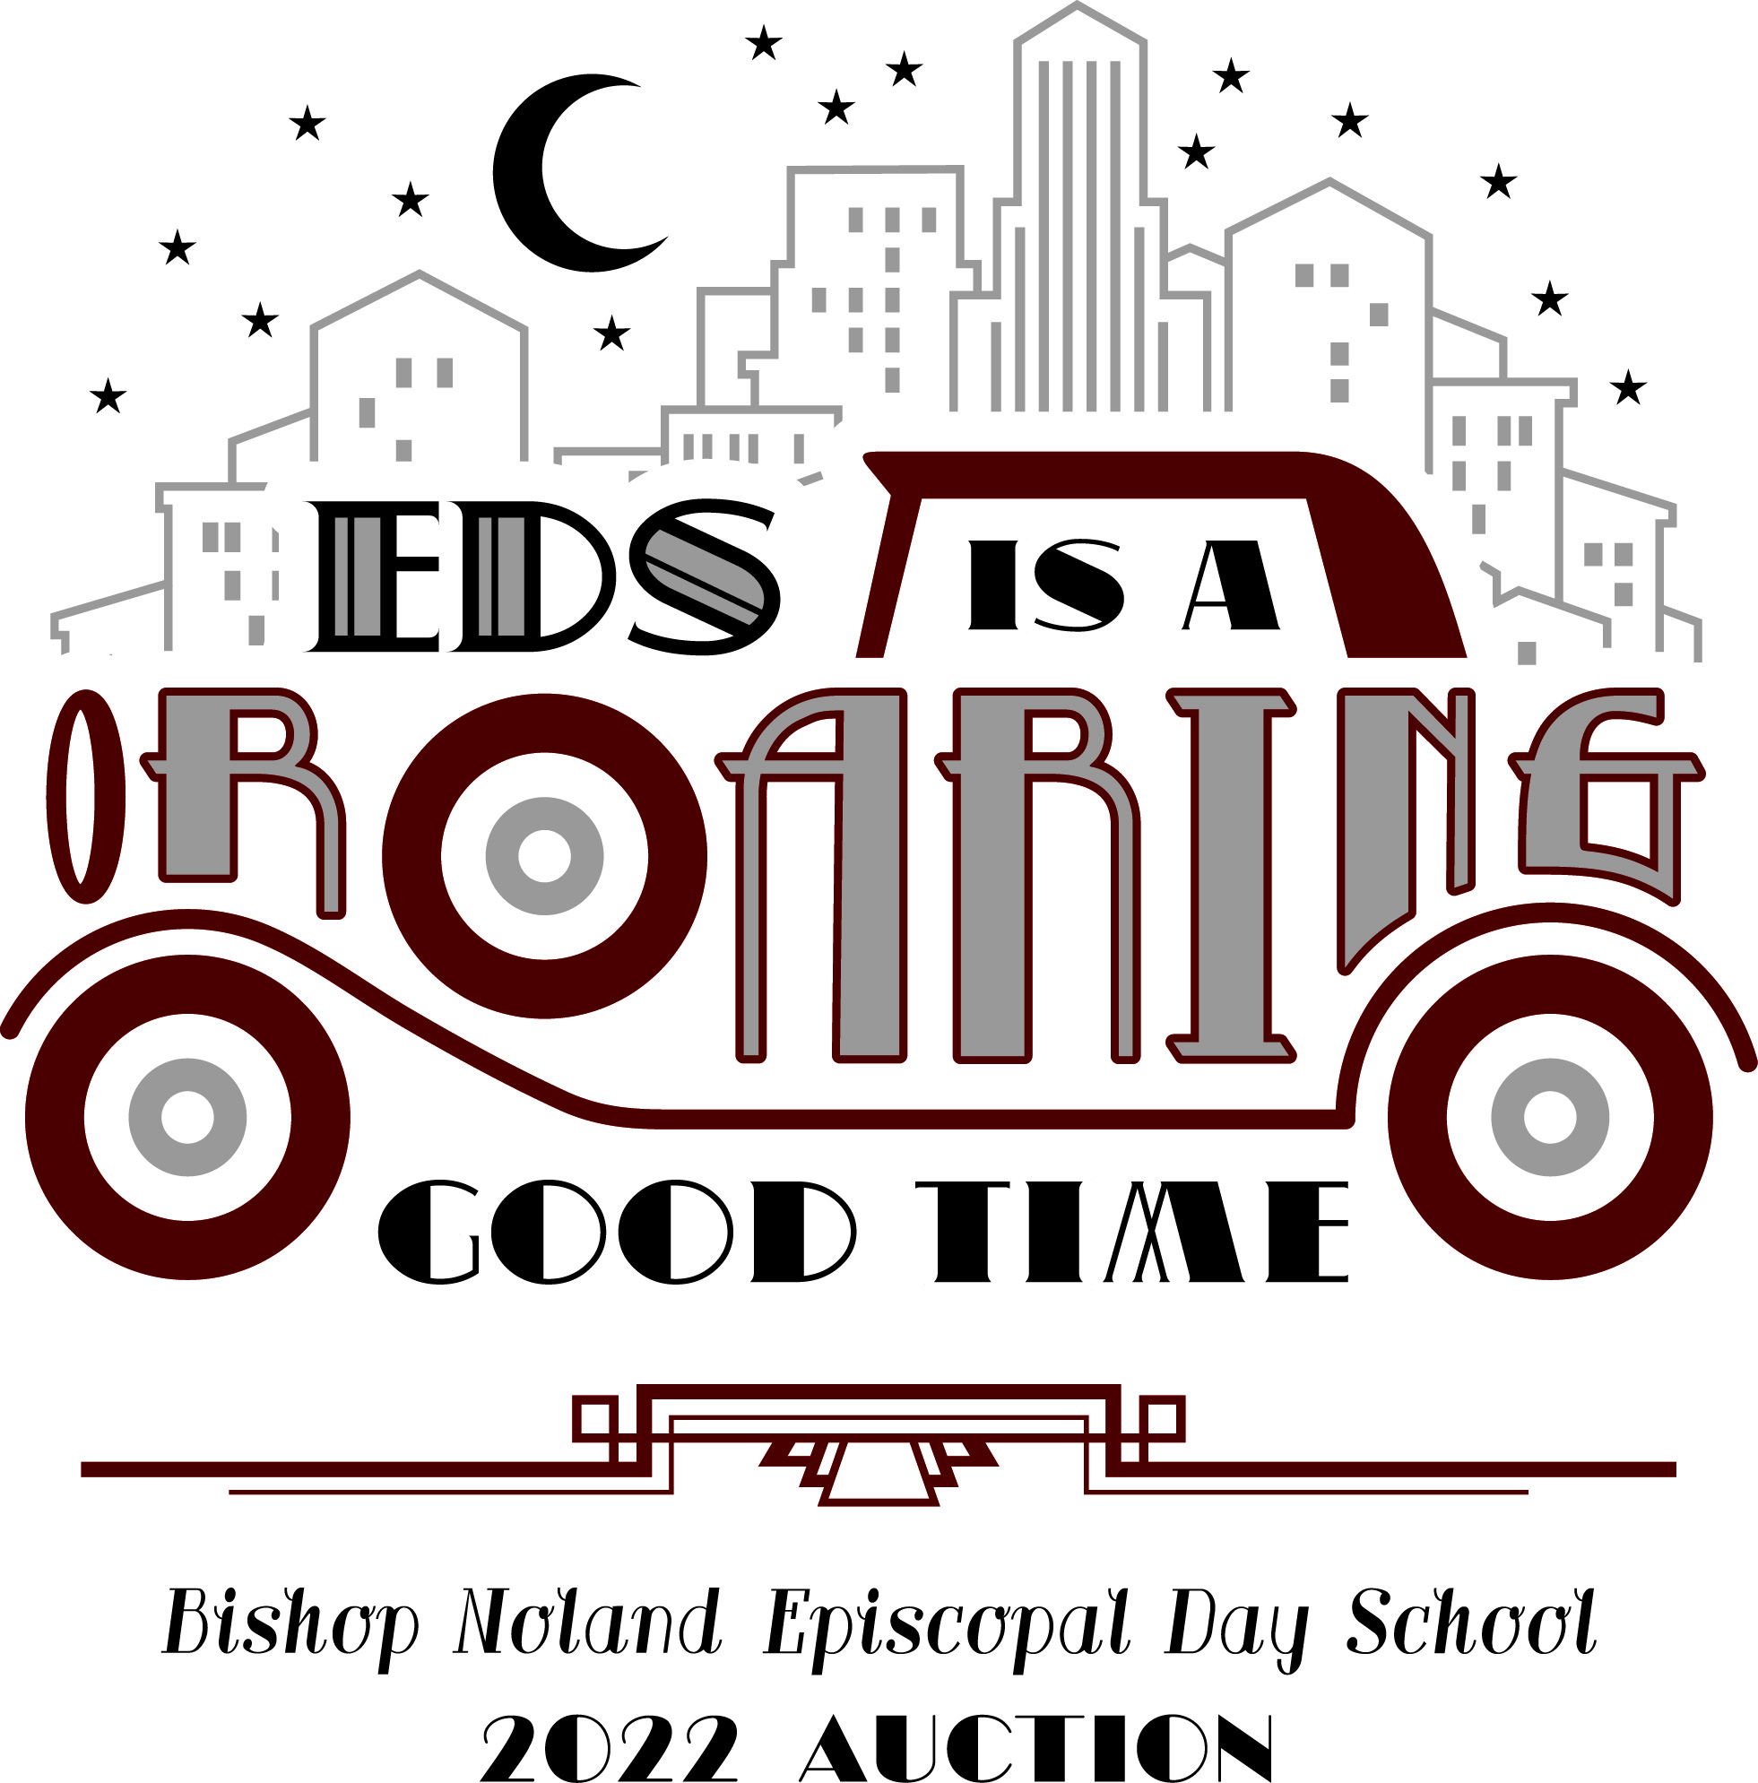
EDS IS A ROARING GOOD TIME
October 27, 2022
Please return form to:
Bishop Noland Episcopal Day School
803 North Division Street, Lake Charles, LA 70601
Email: lardoin@episcopaldayschool.org
(337) 433-5246 Fax: (337) 436-1248
Federal Tax ID 27-0205442

Businesses that donate an item or service will receive complimentary advertising in our auction program.
***Program deadline is Wednesday, October 5th***

Donated Item_________________________________________

____________________________________________________
Item Value Expiration Date
____________________________________________________
Donor Name in Program Donor Contact Phone #

Program Description___________________________________

____________________________________________________

____________________________________________________

Restrictions__________________________________________
____________________________________________________
____________________________________________________

Solicitor Contact Info____________________________________________

