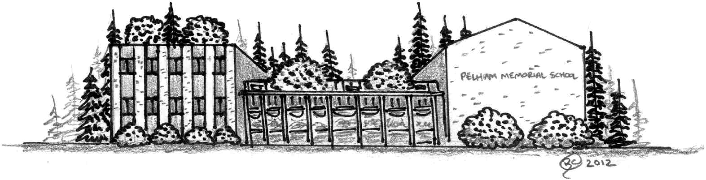
Pelham Memorial School
59 MARSH ROAD
PELHAM, NEW HAMPSHIRE 03076
Telephone (603) 635-2321/Fax (603) 635-2369
www.pelhamsd.org

Stacy Maghakian Katrina Mackey Kimberly Cloutier
Principal Assistant Principal Special Ed. Coordinator

Honor Roll
Trimester 1 - 2020

Grade 8
High Honors
Isabella S, Tatum B, Mya B, Sarah B, Addison B, Alexis B, Sarah B, Katherin C, Alexandra C, Colby C, Isabella D, RIley D, Dylan G, Logan H, Tibor I, Hannah K, Ashton M, Madelyn M, Adam M, Gavin M, Nathan M, Evan M, Mackenzie O, Morgan O, David O, James P, Shea P, Jordan R, Ava S, Olivia S, Samantha T, Kaeden T, Vance V, Emiley V,
Honors
Ryoma A, Rahim A, Akia A, Alexandra B, Vincent B, David B, Allison B, Justin B, Katlyn B, Mark C, Tyler C, Sarah C, Lucas D, Hannah D, Colin D, Briana E, Max F, Lilliana F, Orazio G, Jack G, Madeline H, Steven H, Samantha H, Hayley H Bradley I, Brianna J, Isabella K, Addison K, Summer K, Jacob K, Olivia L, Hailey L, Zaki L, Stephen M, Edward M, Megan M, Georgina M-Q, Nicholas M, Kacey M, Emily N, Bella N, Kaleigh O, Kailyana P, Tierra P, Madilyn P, Pedro Porto , Alexandria P, Cole R, Ava R, Logan R, Dianalease S, Balkaran S, Nathan S, Morghan S, Emma S, Hailey T, Aaron V, Katelynn Z

Grade 7
High Honors
Satsuki A, Morgan B, Aubrin B, Shawn B, Natalia C, Emmalee C, Lucy D, Ella D, Ryan E, Kathryn H, Owen H, Brady H, Adam L, Tristen M, Nolan M, Ava M, Alexia N, Brody P, Ariana Q, Campbell R, Kai S, Matthew S, Mia S, Brady W,
Honors
Morgan A, Haylei A, Bryce A, Hailey B, Aiden B, Quinn B, Jake C, Jacob C, Zachary C, Brooke C, Hailey D, Anthony D, Luke E, Michael F, Dakota G, David G, Sean G, Rayna G, Sophia G, Ashley H, Kevin H, Brady H, Alexander H, Jade J, Lex K, Riley L, Kendra M, Emma M, Joseph M, Julianna M, Madison M, Evan N, Emily N, Brady O, Christopher P, Aryanna P, Alan P, Andrew R, Kevin R, Christian S, Kaitlin S, Samuel S, Michael S, Eve S, Brandon S, Joshua T, Chimaobin U, Logan W, Mateo W,

Grade 6
High Honors
Charlotte A, River A, Aleena C, Ryan D, Jillian G, Liam G, Katelyn L, Khloe L, Benjamin M, Gianna S, Emma S, Rocco S, Emily T, Sarah W,
Honors
Haad A, Bailey A, Caeden B, Katherine B, Nathan B, Jayden B, Kayla B, Kamdin C, Michael C,
Camryn C, Abigail C, Alina C, Charli C, Aidan C, Lia D, Janelle D,Mailyn D, Clayton D, Luis D, Kelci E, Jacob G, Kenzie G, Madison G, Sophia H, Gavin H, Adaline J, Jack K, Joshua K, Abigail K, Hunter K, Jacoby L, Ava L, Nicholas L, Addison M, Ethan M, Ryan M, Nolan M, Scarlett M, Conner N, Ellie O-H, Jacob P, Sunay P, Noella P, Domenic P, Brock P, Alexis P, Matthew R, Travis R, Aubrie R, Anthony R, Danielle R, Max R, Olivia S, Addison S, Christopher S, Julia T, Hannah W,

