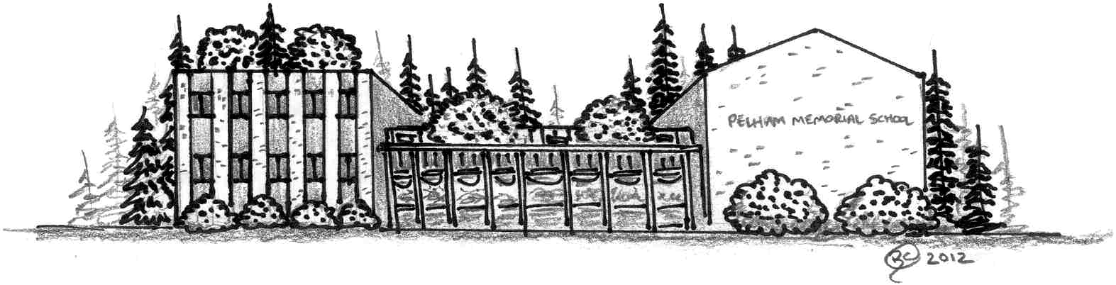

Pelham Memorial School
59 MARSH ROAD
PELHAM, NEW HAMPSHIRE 03076
Telephone (603) 635-2321/Fax (603) 635-2369
www.pelhamsd.org

Stacy Maghakian Katrina Mackey Kimberly Cloutier
Principal Assistant Principal Special Ed. Coordinator

Honor Roll 2020-2021
Trimester 3

Grade 8
High Honors
Isabella A, Akia A, David B, Tatum B, Mya B, Sarah B, Allison B, Addison B, Alexis B, Sarah B, Katherine C, Alexandra C, Mark C, Colby C, Isabella D, Riley D, Dylan G, Madeline H, Logan H, Samantha H, Tibor I, Hannah K, Hailey L, Ashton M, Madelyn M, Adam M, Nathan M, Georgina M-Q, Evan M, Mackenzie O, Morgan O, James P, Shea P, Jordan R, Dianalease S, Ava S, Olivia S, Mo Kan Morghan S, Samantha T, Kaeden T, Vance V, Emiley V,

Honors
Rahim A, Kylie A, Vincent B, Shawn B, Katlyn B, Sarah C, Briana E, Max F, Orazio G, Jack G, Steven H, Hayley H, Bradley I, Brianna J, Addison K, Rocco L, Kevin L, Zaki L, Stephen M, Gavin M, Nolan M, Nicholas M, Kacey M, Austin M, Bella N, Kailyana P, Nikki P, Tierra P, Alexandria P, Cole R, Ava R, Logan R. Dylan S, Chad S, Philip S, Nathan S, Hailey T,
Katelynn Z.

Grade 7
High Honors
Satsuki A, Morgan B, Aubrin B, Shawn B, Natalia C, Jacob C, Brooke C, Lucy D, Ryan E, Michael F, Rayna G, Sophia G, Kathryn H, Owen H, Brady H, Lex K, Nolan M, Alexia N, Emily N, Campbell R, Kai S, Matthew S, Brandon S, Brady W,

Honors
Haylie A, Kiera A, Hailey B, Zachary C, Emmalee C, Hailey D, Ella D, Anthony D, Luke E, Dakota G, David G, Ashley H, Kevin H, Alexander H, Euphemia K, Adam L, Eva L, Casey L, Joelle L, Riley L, Tristen M, Kendra M, Joseph M, Julianna M, Eric N, Evan N, Brady O, Christopher P, Brody P, Alan P, Andrew R, Chrisian S, Kaelin S, Michael S, Mia S, Chimaobim U, Mark W, Molly W, Mateo W.

Grade 6
HIgh Honors
Charlotte A, River A, Caeden B, Shawn C, Alina C, Aleena C, Janelle D, Kelci E, Jillian G, Liam G, Sophia H, Gavin H, Abigail K, Hunter K, Katelyn L, Khloe L, Nicholas L, Ethan M, Ryan M, Jacob P, Dominic P, Alexis P, Max R, Gianna S, Emma S, Rocco S, Emily T, Julia T, Hannah W, Devin Y.

Honors
Haad A, Ammiea A, Anthony A, Ashleigh B, Katherine B, Nathan B, Jayden B-B, Kayla B, Emma B, Kamdin C, Michael C, Camryn C, Charli C, Aidan C, Michael C, Lua D, Riley D, Clayton D, Owen F, Evan F, Jackson F, Jacob G, Kenzie G, Madison G, Adaline J, Jack K, Lydia K, Joshua K, Nicholas L, Ava L, Lily L, Addison M, Benjamin M, Nolan M, Scarlett M, Dana M, Connor N, George O, Ellie O-H, Sunay P, Noella P, Jessica P, Brock P, Edward P, Mathew R, Aubrey R, Travis R, Aubrie R, Danielle R, Olivia S, Hayden S, Addison S, Christopher S, Lexie S, Sarah W.

