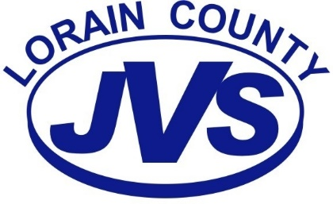
Course of Study Revision
Authorization and Payment Form

According to Article 20.05 All professional teaching staff will conduct a formal curriculum revision every five (5) years in accordance with the administrative rules of the State of Ohio Department of Education. Upon recommendation of the Director of Curriculum & Instruction, High School Principal and acceptance by the Board of Education, the employee will be paid a sum equal to twenty-four (24) times the hourly amount in Article 20.02.

Yes, I have completed and submitted my Course of Study.

Program Name: _____________________________________________
Employee Name: _____________________________________________
Date Approved by the Lorain County JVS Board of Education: _________
Total Payment: $480.00

______ ______________________ __________________________ Instructor Date

___________________________________ __________________________ Principal Date
___________________________________ __________________________ Director of Curriculum & Instruction Date
__________________________________ __________________________ Treasurer Date

