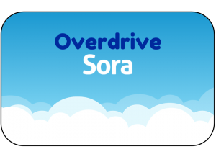

Go to: soraapp.com or https://soraapp.com/library/montroseco
Search for Montrose & Olathe Schools
Our school’s set-up code: montroseco
Custom link from district web page: http://mcsd.lib.overdrive.com/
Student Login: student #
Student Password: Firstinitial Lastinitial @ 6-digit DOB ex. JS@010105
Staff Login: firstname.lastname
Staff Password: district password (IC password)

What does OverDrive offer?
- OverDrive is the industry’s leading source of eBooks and audiobooks.
- MCSD started its OverDrive collection with grant money from the Colorado Department of Education.
- OverDrive’s materials are offered through a 1:1 model; one user at one time.
- OverDrive’s materials can be accessed online any time the student/teacher has access to the internet, or patrons may download the materials to be used when there is no internet access.
- OverDrive's materials can be made available to the entire school district OR limited to a specific site.
- Class sets are available as rentals but on a limited time basis.
- Materials are sorted by age appropriate groupings: juvenile, young adult, staff

Go to: soraapp.com or https://soraapp.com/library/montroseco
Search for Montrose & Olathe Schools
Our school’s set-up code: montroseco
Custom link from district web page: http://mcsd.lib.overdrive.com/
Student Login: student #
Student Password: Firstinitial Lastinitial @ 6-digit DOB ex. JS@010105

Staff Login: firstname.lastname
Staff Password: district password (Infinite Campus password)

What does OverDrive offer?
- OverDrive is the industry’s leading source of eBooks and audiobooks.
- MCSD started its OverDrive collection with grant money from the Colorado Department of Education.
- OverDrive’s materials are offered through a 1:1 model; one user at one time.
- OverDrive’s materials can be accessed online any time the student/teacher has access to the internet, or patrons may download the materials to be used when there is no internet access.
- OverDrive's materials can be made available to the entire school district OR limited to a specific site.
- Class sets are available as rentals but on a limited time basis.
- Materials are sorted by age appropriate groupings:
juvenile, young adult, staff

