- Bookmark our web address in your browsers:
https://mcsdcolo.follettdestiny.com

- Select your site:
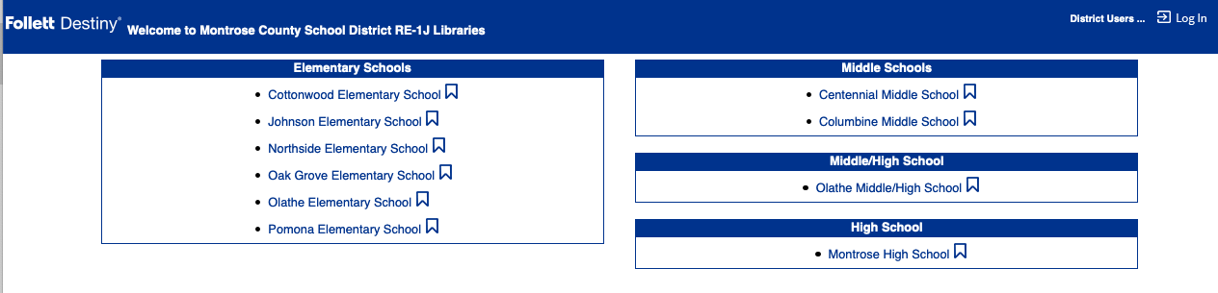

- The landing page is a basic book catalog; you can search for books.

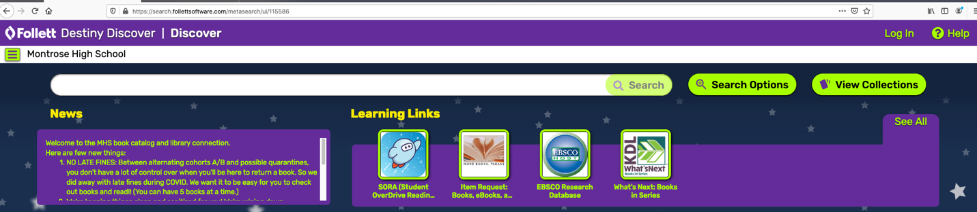

- Login with your district credentials to reserve items, place holds, or renew materials:
Click the District Link to Go to our Authentication Page

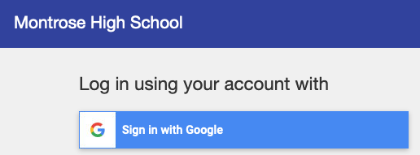
Sign in for Students
Username: Student Number (ex. 1001234)
Password: email password (ex. JR@010705)

- Notice we have access to multiple book formats:
print
eBooks (one user/one copy through SORA or multi-user access through Destiny)
audiobooks
collections

- Under the main menu , you have access to your account.
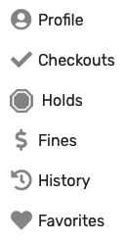
Getting Started with Destiny Discover (Standard View)
https://www.follettcommunity.com/s/article/Getting-Started-with-Destiny-Discover-for-Students-Standard-View-video

Placing Holds in Destiny Discover (Standard View)
https://www.follettcommunity.com/s/article/Placing-Holds-in-Destiny-Discover-Standard-View-VIDEO

Follet eBook and Audiobook Reference Links
https://universalsearchhelp.follettsoftware.com/Content/Reader/_eBook%20Help.htm

- Need Works Cited or Bibliography Help? Did you know that Destiny Discover helps your students with citations and MLA8 or APA format? Students can easily cite materials from our library by copy/pasting from Destiny Discover.

- If you have a question, please contact your librarian, we’ll find the answer.
eBooks and Audiobooks through Sora:
On your iPad or phone: download the Sora App
On a computer or web browser go to: soraapp.com or https://soraapp.com/library/montroseco
Search for Montrose & Olathe Schools
Our school’s set-up code: montroseco
Student Login: student #
Student Password: Firstinitial Lastinitial @ 6-digit DOB ex. JR@010707

