Logan Elm Local School District
Marsha Waidelich, Preschool Coordinator
9579 Tarlton Road, Circleville OH 43113
740-477-4451 or 740-474-7501, ext 1113
marsha.waidelich@loganelm.org

February 2021
Dear Parents/Guardians,

It is time to begin the application process for Preschool at Logan Elm School District for the 2021-2022 school year. Children who are 3 or 4 years old on August 1, 2021 are eligible to apply for preschool; however, we must give priority for enrollment to 4 year olds.

Our preschool classrooms are located at Laurelville Elementary. Preschool classes are ½ day sessions with AM session 9:10-11:40 and PM session 12:50-3:20. Transportation via school bus is available.

If you are interested in applying for admission to our Preschool for 2021-2022 for your child, please complete the application and return by mail, email, or fax:

Marsha Waidelich, Preschool Coordinator
Logan Elm Local School District
9579 Tarlton Road
Circleville OH 43113

Email to: marsha.waidelich@loganelm.org Fax: 740-477-6525

Once I receive your application, I will contact you to schedule a screening appointment. Screening dates and location have not been established at this time.

Please note: We must follow specific guidelines in accepting students for enrollment in our preschool. Completing and returning an application does not guarantee enrollment in our preschool. You will be notified of your child’s status (accepted for enrollment or placed on the wait list) by July 1, 2021.

Please contact me at 740-477-4451 or marsha.waidelich@loganelm.org if you have any questions.

Sincerely,

Marsha L. Waidelich
Preschool Coordinator

2021-2022 Logan Elm Local School District Preschool Application

Student Information
Name:________________________________________________________________________
(last) (first) (middle)

Birthdate: ___________________ County of Residence: ___________________

Address: ________________________________________________________ (Street)

_________________________________________________________ (City, State, Zip Code)

Transportation Choice:
______ Student will NOT ride bus; parent will transport
_____ Student will ride bus to/from home address
_____ Student will ride bus to/from another address (please list):
_______________________________________________________________
AM or PM placement is dependent on bus routes. Generally, students riding Pickaway County routes attend the AM session while students riding Hocking County routes attend the PM session. Students who do not ride the bus may attend either session.

Parent Information:
Mother’s name: ________________________________ Phone #___________________________
Email address: _____________________________________________________________________

Father’s name: _________________________________ Phone # ___________________________
Email Address: _____________________________________________________________________

Parents are: _________married ______divorced __________ never married
If divorced, which parent is the residential parent for school enrollment? _______________________

If child does not reside with parents:
Guardian’s name: _________________________________ Phone # ____________________________
Email address: ________________________________________________________________________
Is guardianship/custody granted by:
______ Court Order ______ Grandparent POA/Affidavit _____Foster placement

Enrollment Options:
Please check the enrollment options you would consider:
________ Full tuition paid by parents ($125 per month)
________ ECE grant tuition waiver--based on income, see next page for information

Do you have any concerns with your child’s development in the following areas?
_______ Speech & Language/Communication _______ Delayed Development
_______ Motor Skills—fine or gross _______ Other: ____________

Parent/Guardian Signature: _______________________________________________________

For Students whose household income is below 200% of the Federal Poverty Level, preschool tuition may be waived (free) or reduced ($62.50 per month).

In order to qualify for the ECE grant tuition waiver, parents must complete an ECE Screening Tool and provide proof of income at the time of screening and enrollment.

The Federal Poverty Level Income Chart for 2021 is listed below for reference.

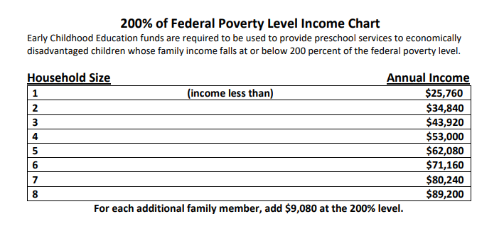

In addition to income-based qualifications:
Students who are court-placed with someone other than their parents, under the jurisdiction of Job & Family Services, may also qualify for free tuition.

Students who have been identified as having a disability are not subject to tuition for preschool.

