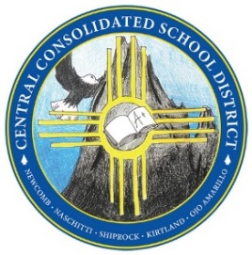
CENTRAL CONSOLIDATED SCHOOL DISTRICT
District Administration Complex
P.O. Box 1199, Shiprock, NM 87420
US Hwy 64 Old High School Rd
Administration • 505-368-4984 • Fax 505-368-5232
“A Community of Learners Dedicated to Building Lives”

Spring 2022 Youth Forward Family Survey Parent Letter Template

Dear Parents/ Guardian;
Thank you for participating in the 2022 Youth Forward Family Survey. This survey is specifically designed to gather feedback from all our parents and family members in order to make decisions with your voice in mind.
Your feedback will help us paint a picture of what our students need now, beyond what their test scores say. We will use this information to make more holistic and equitable decisions for our students and the families and staff who support them.
You are providing valuable feedback about your unique experience with your school. Please remember that no one at your school will see your responses.

See specific survey information below:

- The 2022 Youth Forward Family Survey is part of our efforts to collect feedback from all stakeholders. It is intended for parents or guardians with children in grades K-12 attending a New Mexico public or charter school.

- The family survey is available in English and Spanish from April 19-May 9, 2022 through this URL: https://tinyurl.com/yforwardfs22.

- The survey can be taken through any device, including a smartphone.

- The survey will take 10-15 minutes to complete. Please avoid navigating away from the survey before completion.

- The survey is anonymous, and individual responses will not be shared with the school.

- Families can take the survey for more than one school-attending child using the same link.

- If a response to a question is not known or familiar, it can be skipped.

If you have any questions or need assistance, please call your child’s school. You can also see more information in our website, https://www.ccsdnm.org/Data.aspx.

Thank you again for your participation.

