All students will be registering for next year's courses online.

The following Will help you navigate the webpage to sign up for your courses.
STEP 1: Login to your PowerSchool account using your username and password.
You MUST login through WWW.TROYAREASD.ORG

STEP 2: On the left sidebar, locate and click on Class Registration. A set of course selection boxes should appear. [If, for some reason, you don't see the course selection boxes, click on another option on the side, like Grade History, and then come back to Class Registration.]
Navigation
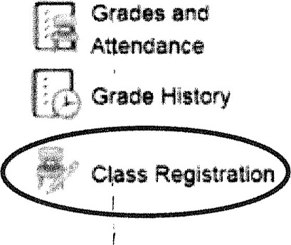

STEP 3: Using your course selection worksheet as a guide, you will now select the courses that fulfill your schedule requirements for the coming academic year. Here are some things to keep in mind:
- If a category says "Required" (e.g. Health/PE, English, etc.), then you must sign up for at least the minimum number of courses in that category.
- World languages are not marked as Required, but it is highly recommended that all students consider taking at least one world language.
- You must select enough elective courses to ensure that you are carrying a minimum of 7 credits. You will not be allowed to complete and save your registration if you sign up for less than 7 credits.
- You must select 3 alternative elective courses in case you do not get the original electives you chose.
- Pay attention to course requirements.

- MAKING YOUR COURSE SELECTIONS
- Click the pencil icon in each Course Group (e.g. math).
- Check the desired course/courses
- Click submit in the bottom right-hand corner when finished.

STEP 4: When you are finished selecting your courses from all the Course Groups, you should see Green Check Marks (instead of REB Exclamation Points) to the right of the pencil icons. This indicates that you have successfully completed each Course Group. To complete your registration, be certain to click the SUBMIT button on the lower right-hand corner of the registration screen.

