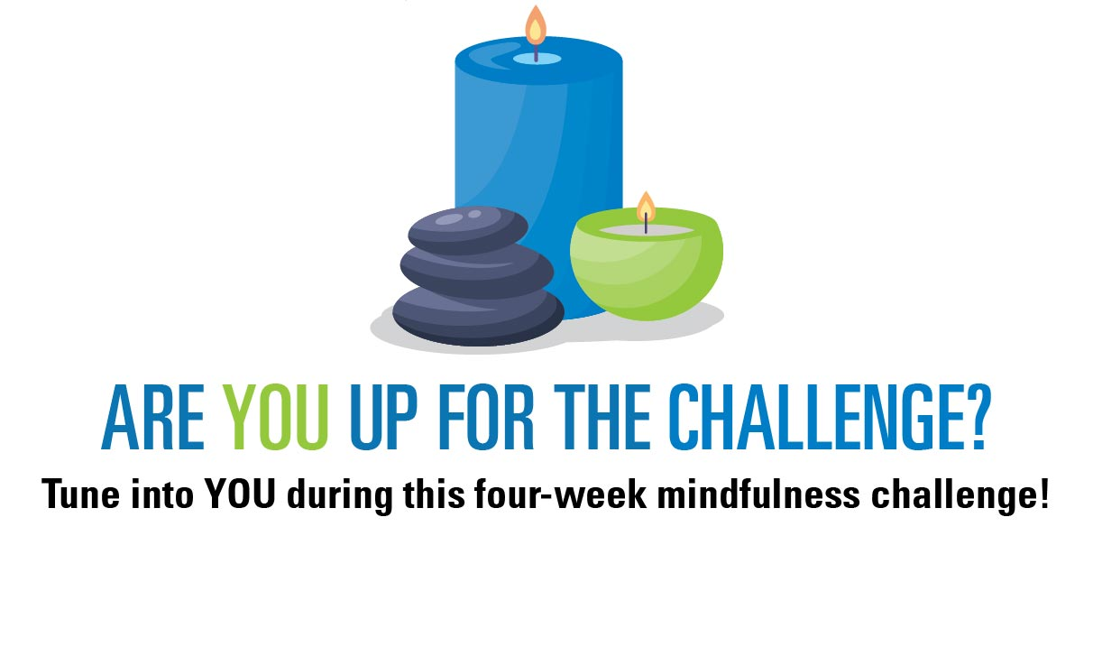
(Enter 4-week time frame)

Mindfulness is being present in the moment and actively aware of your feelings, thoughts, and behaviors. When we practice mindfulness, we tune into what we’re sensing in the present moment rather than worrying about the past or thinking about the future.
Join us during our Tune into YOU program, which challenges you to accomplish a different mindfulness activity each day for four-weeks. By completing these activities, you will be able to better focus on the present moment and reduce stress.

How to Sign Up for the Challenge?
The four-week challenge will kick off (enter start date) and end (enter end date). Please register by (enter registration information here.

How to Win?
Simply complete the four-week challenge and submit your tracker to be entered into a raffle to win (enter prizes/incentives).

If you have any questions about the challenge, please reach out to
(enter contact person information here).

