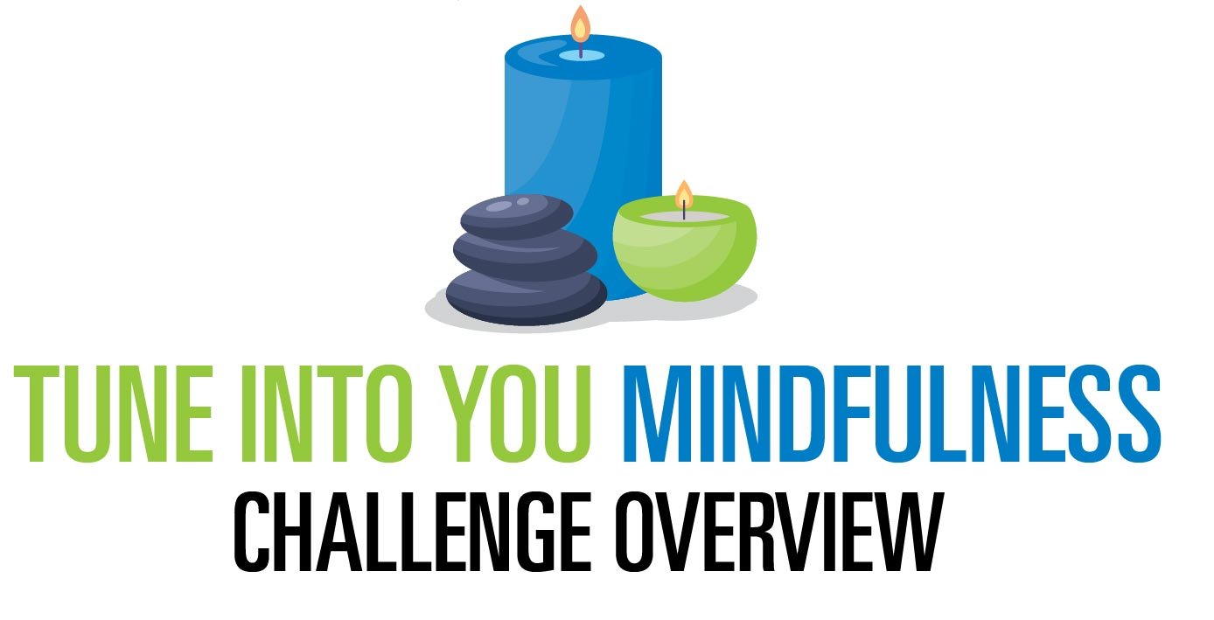
Mindfulness is being present in the moment and actively aware of your feelings, thoughts, and behaviors. When we practice mindfulness, we tune into what we’re sensing in the present moment rather than worrying about the past or thinking about the future.
Join us during our Tune into YOU program, which challenges you to accomplish a different mindfulness activity each day for four-weeks. By completing these activities, you will be able to better focus on the present moment and reduce stress.
The 4-week challenge kicks off (enter start date) and ends (enter end date).

What to Do During the Challenge?
Using the tracker, mark an “X” through activities as you complete them each day. Follow the activities on the calendar or replace them with your own. Challenge yourself to complete a new activity every day.

At the end of the challenge, please turn in completed tracker with your name and contact number to (enter how to submit trackers) by (enter dates which trackers must be submitted by) to be eligible for prizes, which includes (enter prize/incentives).

If you have any questions along the way, please reach out to
(enter registration information here).

