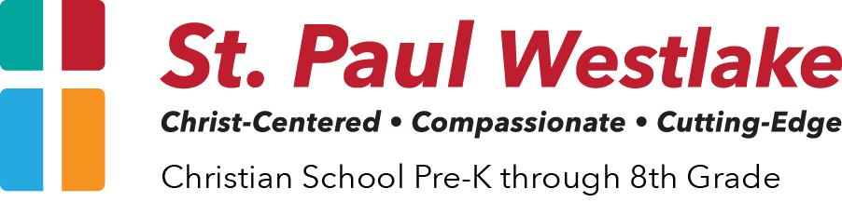

Student Success & Support Coordinator
Job Description

Our Mission
St. Paul Westlake provides an academically excellent education for students in an environment that is Christ-Centered, Compassionate, and Cutting-Edge.

Job Title
Student Success & Support Coordinator

Reports To
School Principal

Overview
St. Paul Westlake is looking for a dynamic, creative, and inspiring self-starter who believes in, has a knowledge of, and passion for, private Christian education. This person will provide leadership for and oversee the Student Success department.

Qualifications
Preferred: Master’s Degree in Special Education (or similar); No less than 5 years related work experience

Required: Bachelor’s Degree in related field; Intervention Specialist Licensure or able to get

Primary Objectives
Responsible for the implementation, evaluation, and operation of the Student Success program while leading intervention efforts for students and supervising all student success team members and related staff in coordination with the school Principal.

General Responsibilities
- Oversee all programs and services for students with accommodation plans including IAPs (Individual Accommodation Plans), IEPs (Individualized Education Program), Student Success Plans, and other academic or behavior interventions.
- Work with students in direct support situations (1-on-1), small group, or other methods of intervention to support their academic, behavioral, social, and spiritual development.
- Collect, prepare, file, and submit data, applications, and other necessary documentation to ensure compliance with any Federal, State, and/or Local grant programs including, but not limited to: Title 1 funding, Jon Peterson / Autism Scholarships, IDEA, etc.
- Oversee the implementation of appropriate assessments and assessment programs for learners within the Student Success programs.
- Create systematic methods of student assessment and evaluation to identify learners who need and qualify for academic or behavioral intervention.
- Provide professional knowledge, support, and ideas to classroom teachers regarding supporting learners with academic or behavioral needs within the classroom.
- Engage in regular and effective communication between school staff, student, and families as it pertains to evaluation or implementation of programs.
- Establish program policies, methodologies, and guidelines to ensure student success and achievement towards stated goals.
- Supervise and support the work of department staff members.
- Investigate, recommend, and/or execute professional development opportunities for staff members of St. Paul Westlake.
- Cultivate a culture of collaboration between members of the Student Success department and classroom teachers.
- Ensure effective transition of services information about students from one grade to the next.
- In cooperation with the Auxiliary Clerk, act as liaison between St. Paul Westlake School and local public school districts.
- Ensure student support plans are reviewed and updated as needed and without delay.
- Ensure the school’s compliance with any state scholarship programs including, but not limited to, Jon Peterson Scholarship Program and the Autism Scholarship Program.
- Provide professional recommendations and knowledge in regard to adoption and development of school policies and procedures particularly as it pertains to student support initiatives (i.e. – Special Education)
- Stay up to date on state and federal rules, regulations, and qualifications, particularly the Ohio Operating Standards for the Education of Children with Disabilities.
- Other job assignments as appropriate as agreed upon by the employee and Principal.

JOB RELATED SKILLS & ABILITIES
- Demonstrate commitment to private Christian Education
- Be familiar with community-based support resources for students, teachers, and parents. (e.g. - Counseling centers, therapists, tutoring services, mental health, etc.)
- Ability to use good judgement to manage and impart information to a range of students, families, businesses, organizations, media sources, and other stakeholders
- Ability to work professionally in an educational environment
- Ability to appropriately handle confidential information
- Ability to make administrative and procedural decisions regarding sensitive and/or confidential issues
- Ability to foster a collaborative work environment
- Ability to organize, prioritize, schedule, and complete job tasks
- Ability to communicate clearly and accurately in written and spoken word
- Ability to travel within and out of state for meetings, workshops, etc.
- Demonstrate excellent interpersonal communication skills

JL 4/13/2021

