St. Baldrick’s Day T-Shirts!
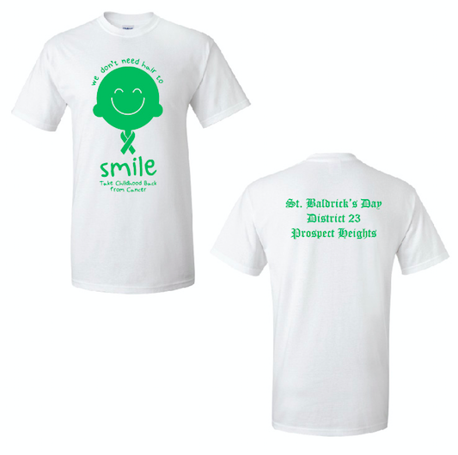
Friday March 22, 2019
Help us fight this battle together by purchasing a St. Baldrick’s Day t-shirt. $10.00
A portion of the proceeds will go to the SB foundation
Size Availability: Youth S-XL / Adult S-XL
Please select the quantity and size (specify YOUTH OR ADULT)
Return the bottom portion and payment to your advisor/teacher by 3/8/19.
CASH PREFERRED or CHECK MADE OUT TO DISTRICT 23
