During program year 2024-2025, children enrolled in a sponsored USDA participating school, Residential Child Care Institution (RCCI) or other institution may be eligible to receive Free and Reduced Price Meals benefits or Free Special Milk benefits if your family’s income qualifies. Enrolled students from a household receiving SNAP, FDPIR or TANF assistance are automatically eligible to receive free meal benefits.
INCOME ELIGIBILITY GUIDELINES (Effective from July 1, 2024-June 30, 2025)
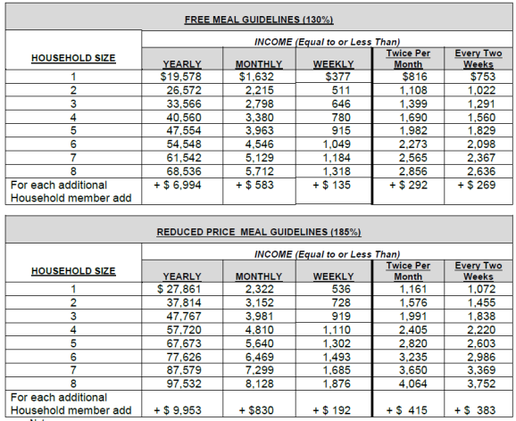

An application is not required for free meal benefits for Assistance Program participants (ex. SNAP). Children in the household of Assistance Program participants are eligible for free meal benefits, and this free benefit is extended to all children in the household. Contact your child’s school if not all children in the Assistance Program household are not receiving free benefits.
When known to the LEA, households will be notified of any child’s eligibility for free meals if the individual child is considered under “Other Source Categorically Eligible” where the child is categorized or defined by law as foster, homeless, migrant, runaway, enrolled in an eligible Head Start, or enrolled in an eligible Kindergarten class. That designated child is free and the benefit is not extended to others. If any child were not listed on the notice of eligibility, please contact the child’s school about their eligibility through an Other Source Categorically Eligible Program or submit a free and reduced income application. This institution is an equal opportunity provider.
Households must contact their child’s school to apply for free and reduced-price meals or free milk if the school has the Special Milk Program. The child’s school will give instructions of how to submit an application to a school or LEA office. Direct any questions about the application process to the child’s school. If the household is receiving benefits under Assistance Programs or Other Categorically Eligible Programs and are not notified by the school of their free meal benefits, the household should call their child’s school. If the household has been notified of their children’s eligibility, but chooses to decline the meal benefits, the household should contact their children’s school. A household may apply for benefits at any time during the school year. Children of parents or guardians who become unemployed or experience a financial hardship mid-year may become eligible for free and reduced-price meals or free milk at any point during the school year. Only one application is required for all children in the household attending schools in the same LEA. Only the last four digits of the Social Security Number of the household’s primary wage earner or another adult household member (or an indication of “none”) is needed when submitting the application. Information submitted on the application may be subject to verification.

Special Supplemental Nutrition Program for Women, Infants and Children (WIC) participants may be certified as eligible for free and reduced-price meals through the application process. Categorical eligibility for free meal benefits is extended to all children in a household when the application lists an Assistance Program’s case number for any household member. Households with any member who is currently certified to receive Assistance Program benefits may submit an application with abbreviated information as indicated on the application and instructions. Households with children who are categorically eligible through an Other Source Categorically Eligible designation may be eligible for free benefits and should contact the school or LEA for assistance in receiving benefits. A foster child is categorically eligible for free meals and may be included as a member of the foster family if the foster family chooses to also apply for benefits for other children. Including children in foster care as household members may help other children in the household qualify for benefits. If non-foster children in a foster family are not eligible for free or reduced-price meal benefits, an eligible foster child will still receive free benefits.

An application for free and reduced-price benefits cannot be approved unless complete eligibility information is submitted, as indicated on the application and in the instructions. A household may appeal the application decision, using the hearing procedure described in the LEA’s free and reduced-price policy statement.
For up to 30 operating days into the new school year (or until a new eligibility determination is made, whichever comes first) an individual child’s free or reduced-price eligibility status from the previous year will continue within the same LEA. When the carryover period ends, unless the household is notified that their children are directly certified or the household submits an application that is approved, the children’s meals must be claimed at the paid rate. Though encouraged to do so, the LEA is not required to send a reminder or a notice of expired eligibility

In accordance with federal civil rights law and U.S. Department of Agriculture (USDA) civil rights regulations and policies, this institution is prohibited from discriminating on the basis of race, color, national origin, sex (including gender identity and sexual orientation), disability, age, or reprisal or retaliation for prior civil rights activity.
Program information may be made available in languages other than English. Persons with disabilities who require alternative means of communication to obtain program information (e.g., Braille, large print, audiotape, American Sign Language), should contact the responsible state or local agency that administers the program or USDA’s TARGET Center at (202) 720-2600 (voice and TTY) or contact USDA through the Federal Relay Service at (800) 877-8339.
To file a program discrimination complaint, a Complainant should complete a Form AD-3027, USDA Program Discrimination Complaint Form which can be obtained online at: https://www.usda.gov/sites/default/files/documents/ad-3027.pdf, from any USDA office, by calling (866) 632-9992, or by writing a letter addressed to USDA. The letter must contain the complainant’s name, address, telephone number, and a written description of the alleged discriminatory action in sufficient detail to inform the Assistant Secretary for Civil Rights (ASCR) about the nature and date of an alleged civil rights violation. The completed AD-3027 form or letter must be submitted to USDA by:
- mail:
U.S. Department of Agriculture
Office of the Assistant Secretary for Civil Rights
1400 Independence Avenue, SW
Washington, D.C. 20250-9410; or
- fax:
(833) 256-1665 or (202) 690-7442; or
- email:
Program.Intake@usda.gov
This institution is an equal opportunity provider.

