Anthony Wayne Alumni Association
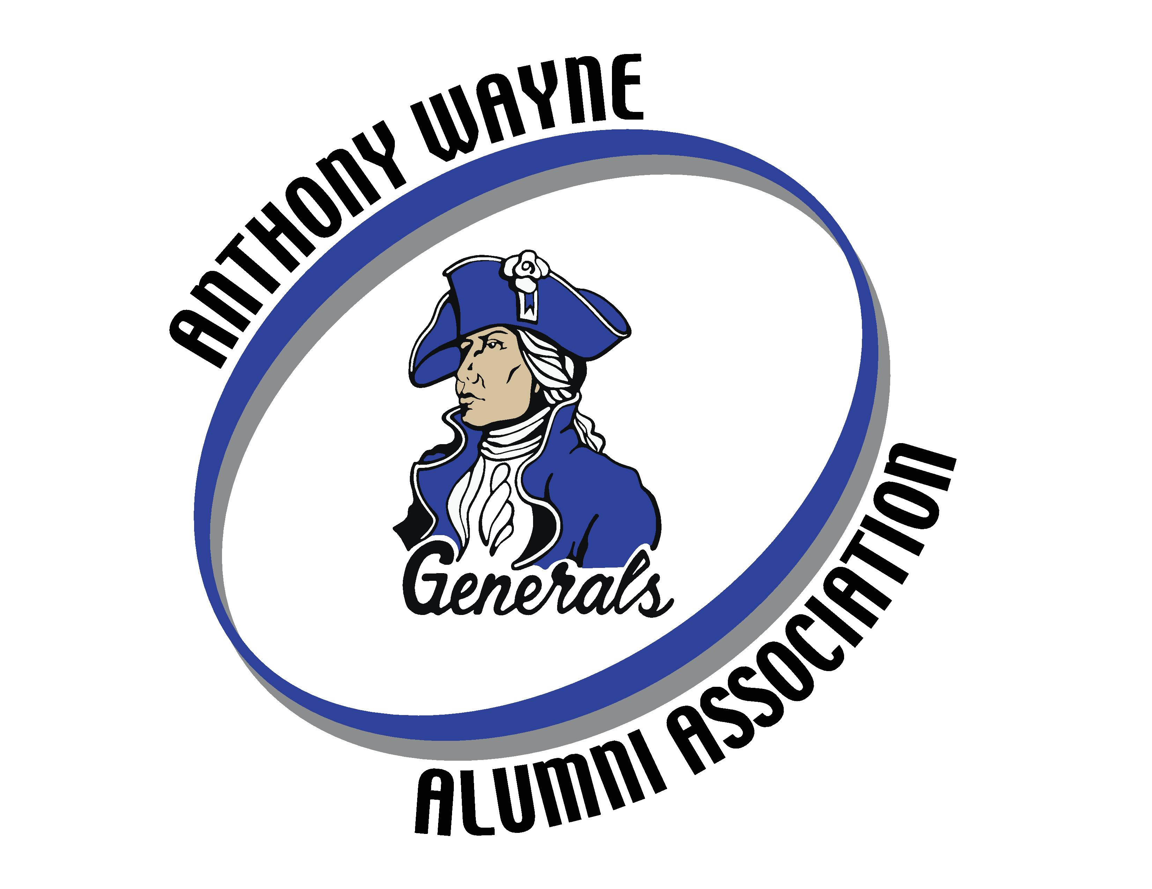
Scholarship Application
For Anthony Wayne High School/Penta Career Students
Deadline: March 23, 2023; 2:35pm
AWAA Mission Statement: To develop, guide and honor connections made among Anthony Wayne Alumni.
Please read the following information and ensure you meet all of the eligibility criteria before completing this application.
The Anthony Wayne Alumni Association scholarship is awarded on the basis of student achievement. The process may involve consideration of financial need, academic and athletic achievement and demonstrated volunteer commitment. Scholarships are awarded based on committee review recommendations. The scholarship may be applied to tuition, fees, books, supplies and equipment required for coursework at an accredited college, university or trade school in the United States.
The Anthony Wayne Alumni Association provides a $1,000 one-time, non-renewable scholarship. Please note the following scholarship categories, numbers of each, the required GPA and any other requirements.
(6) “Generals” Scholarships-GPA required: 82% or 2.75
-funded by 50/50 sales, memberships, donations and other fund-raisers
(1) Plymale Family Scholarship-GPA required: 82% or 2.75
(Applicant must submit a letter of recommendation from a faculty member, coach, or advisor)
-Funded by the Plymale family in honor of their parents, Charles and Rachel Plymale.
(1) Les Disher Ag.-Sci. Scholarship-GPA required: 82% or 2.75
-funded by Mrs. Doris Disher
(1) Fred Dais Future Educator Scholarship-GPA required: 82% or 2.75
-funded by Mr. Fred Dais (A.W. ’60)
(1-2) Public Safety Scholarships-GPA required: 75% or 2.5
-funded by area public safety forces and government entities
(1-2) Patrick Short Skilled Trades Scholarship-GPA required: 75% or 2.5
-funded by Mr. Pat Short (A.W. ’72)
(1) Randee DeBolt Masciola Nursing/Public Health Scholarship-GPA required: 88% or 3.5
(Female athlete, one or more varsity sports, attending an Ohio school)
-partially funded by Ms. Randee DeBolt Masciola (A.W. ’91)
(1) Military Dependent Scholarship-GPA required: 82% or 2.75
(A dependent of a current guard, reserve or active-duty personnel. A copy of DD214 and current
military I.D. is required-these will be kept confidential)
-partially funded by Dr. Brad Contat (AW Local Schools, Human Resources Director and
U.S. Army veteran) and other area veterans
(con’t.)
(1) History Scholarship-GPA required: 82% or 2.75
(For students who enjoy, actively study history, and use their historical knowledge to become
participants in the civic lives of their communities)
-funded by the Waterville Historical Society in partnership with the AW Alumni Assoc.
(1) The Jim Rider Band Scholarship-GPA required: 82% or 2.75
(Scholarship will go to a graduating senior band member who is dedicated, enthusiastic, and hard
working. Attend a two-year or four-year college/university. Do not have to be studying music. Must
enclose a written recommendation by band director (head or assistant) or a school counselor.)
-funded by friends of Jim Rider (AWHS '72)
(1) The Don Ondrus Math Educator Scholarship-GPA required: 82% or 2.75
(Attend a four-year college/university to become a math teacher Must enclose a written
recommendation from high school math teacher or school counselor.)
-funded by Mr. and Mrs. Don Ondrus (AWHS faculty 1970-2007).
Eligibility Criteria
To be considered for an Anthony Wayne Alumni Association scholarship, all students must meet the following criteria:
- Be enrolled as a senior and a current student at Anthony Wayne High School, Penta Career Center, or home-schooled and residing in the Anthony Wayne district.
- Be a United States citizen.
- Must be planning to enroll in a two or four-year college/university or trade school in the fall of 2023 as a full time, degree/certification seeking, first year student. Fields can include: Agriculture, nursing, technology, public safety, electrical, pipefitting, etc. This is not an inclusive list of career choices. All other career options will be considered as well.
- Demonstrated volunteer commitment of time in the school and/or community.
- Have met a minimum cumulative grade of either 88%/B+/3.5 GPA, 82%/B-/2.75 GPA or 75%/C/2.5 GPA. (Depending on which scholarship you are applying for).
- Be available for a possible interview.
- Complete and submitted the application by the deadline date of March 23, 2023 at 2:35pm.

Instructions:
Typed responses are preferred but not required. Please respond to each blank field.

Personal Information:
Student first, middle initial and last name
Mailing address
Home phone
Cell Phone
Email address
Date of birth
Institution you will be attending for the upcoming school year:_______________________
Date of anticipated college/school graduation:
Intended field of study: ____________________________________________________
*Which scholarship are you applying for?________________________________________
(You can be considered for a “Generals” scholarship as well as a specific category.)
Please give the names of three adults (other than family members) and contact numbers who can provide a reference. If the scholarship you are applying for requires a written recommendation, please include it.
Name Phone Number
1) _____
2) _____
3) _____
Your cumulative GPA-must be equal to or greater than what is listed in the Eligibility Criteria on page 1:
Your class rank at Anthony Wayne High School in Whitehouse, Ohio: ______
Time(s) you are available for an interview (if needed):
____________________________________________
In what ways have you volunteered your time and efforts to support your community and/ or school? List or explain the types of volunteering. You may attach your response if you wish,

*NOTE: For ALL applicants except the History scholarship-Please state, in your own words,
an essay answering the following topic:
”Evaluate a significant ethical dilemma, experience, achievement or risk you have faced
and its impact on you.”
*NOTE: If you are applying for the HISTORY SCHOLARSHIP, the topic is:
“Which historical event during your lifetime do you believe will have
the largest influence upon you and the United States and why.”
(No more than 600 words. You may attach your response if you wish.)

Save and print the application.
- Once the application is completed, save the file as your name plus date (Ex. Janedoe03022023)
- Print the application, sign, date and submit. Make sure to have a parent/legal guardian sign below as well.
- Please include a copy of your senior photo with your application file. The photos of the scholarship award winners will be released to the Mirror and used on the AWAA Facebook page.

*Email your completed file and photo to awalumni@hotmail.com

Application must be submitted by March 23, 2023, 2:35pm
The information provided in my application is complete and accurate, to the best of my knowledge. I understand that false information on this application may disqualify me from receiving the
Anthony Wayne Alumni Association Scholarship.

Student Signature __ Date

*Signature of parent/legal guardian _________________

Date _______________

*NOTE: If your son/daughter is applying for the “Military Dependent Scholarship” please include a copy of your DD Form 214 and your Military ID to indicate current status. These forms will be kept confidential.

