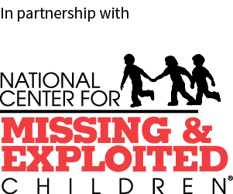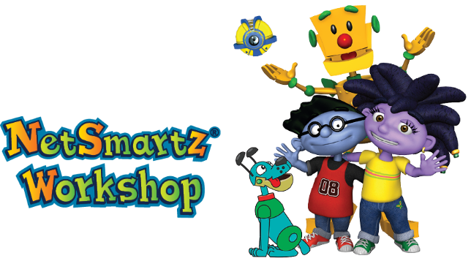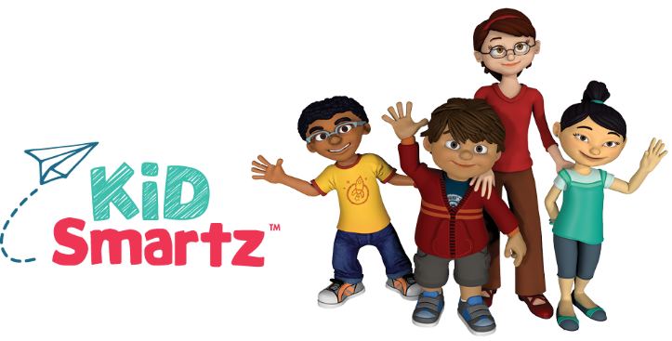

NCMEC’s KidSmartz program, sponsored by Honeywell, educates families about preventing abduction and empowers children in grades   
K-5 to practice safer behaviors. The KidSmartz presentation teaches K-5 students about   
the 4 Rules of Personal Safety. This is a fun, interactive presentation that engages children using age-appropriate demonstrations, quizzes, music and animated videos.

NCMEC’s NetSmartz program educates parents and children in grades K-12 about online safety and digital citizenship. Their presentations for younger children, tweens, teens and parents/guardians cover issues like cyberbullying, inappropriate content, privacy and sexting. These presentations engage audiences using discussion, videos and practical tips for staying safer online.

Schedule a presentation

If you are interested in scheduling a presentation or learning more about the Childhood Smart Program, please do not hesitate to contact me. I look forward to hearing from you.

Logan Elm School DIstrict,

I would like to take this opportunity to introduce you to a new community outreach initiative called ***Childhood Smart Program*** presented by the United States Secret Service. Most people know that the Secret Service protects the President of the United States, but many do not know we also help investigate cases of missing and exploited children and provide child safety resources to children and families.

Our Childhood Smart Program provides free presentations and other materials to help teach K-12 students how to be safe online and offline. I welcome the chance to speak with you about scheduling one or more of these free presentations at your school.

About the program

The Childhood Smart Program was created in partnership with the National Center for Missing & Exploited Children (NCMEC) to help educate parents and children about computer and personal safety. The child safety experts at NCMEC create educational resources for parents and K-12 students. The Secret Service helps to disseminate these resources to schools and communities across the nation. We are proud to partner with NCMEC to bring these free prevention materials to schools.

Special Agent Britney R. Hays

United States Secret Service

Britney.hays@usss.dhs.gov

(202) 577-9658 – Cell

