SCHEDULE OF EVENTS
8:30 am Coaches Meeting and Scratch meeting at the Finish Line.

RUNNING EVENTS FIELD EVENTS

10:30 GIRLS 100 M HURDLES 9:00 BOYS - LJ (V-N), SHOT (V-N), JAV (N-V)
BOYS 110 M HURDLES GIRLS - DISCUS (V-N), LJ (V-N), HJ (N-V)
GIRLS 100 M DASH 10:00 BOYS - PV (V-N)
BOYS 100 M DASH 10:15 Finals Boys and Girls LJ (V)
GIRLS 1600 M RUN 11:00 BOYS HJ (N-V)
BOYS 1600 M RUN GIRLS JAV (V-N), SHOT(N-V)
GIRLS 400 M RELAY 12:30 BOYS DISCUS (V-N)
BOYS 400 M RELAY GIRLS PV (N-V)
GIRLS 400 M DASH *Boys and Girls Triple jump will begin
BOYS 400 M DASH immediately following the Long Jump
GIRLS 300 M HURDLES
BOYS 300 M HURDLES
GIRLS 800 M RUN
BOYS 800 M RUN
GIRLS 200 M DASH
BOYS 200 M DASH
GIRLS 3200 M RUN
BOYS 3200 M RUN
GIRLS 1600 M RELAY
BOYS 1600 M RELAY

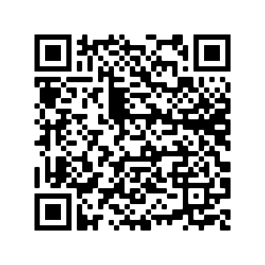
https://play.google.com/store/apps/details?id=com.active.aps.trackandfield&hl=en_US&gl=US
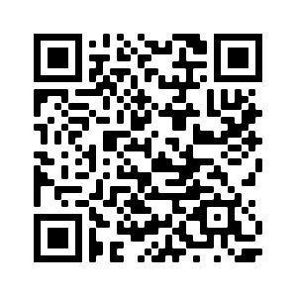https://apps.apple.com/us/app/track-field-meet-mobile/id982356677

