­­

DECK OF FITNESS

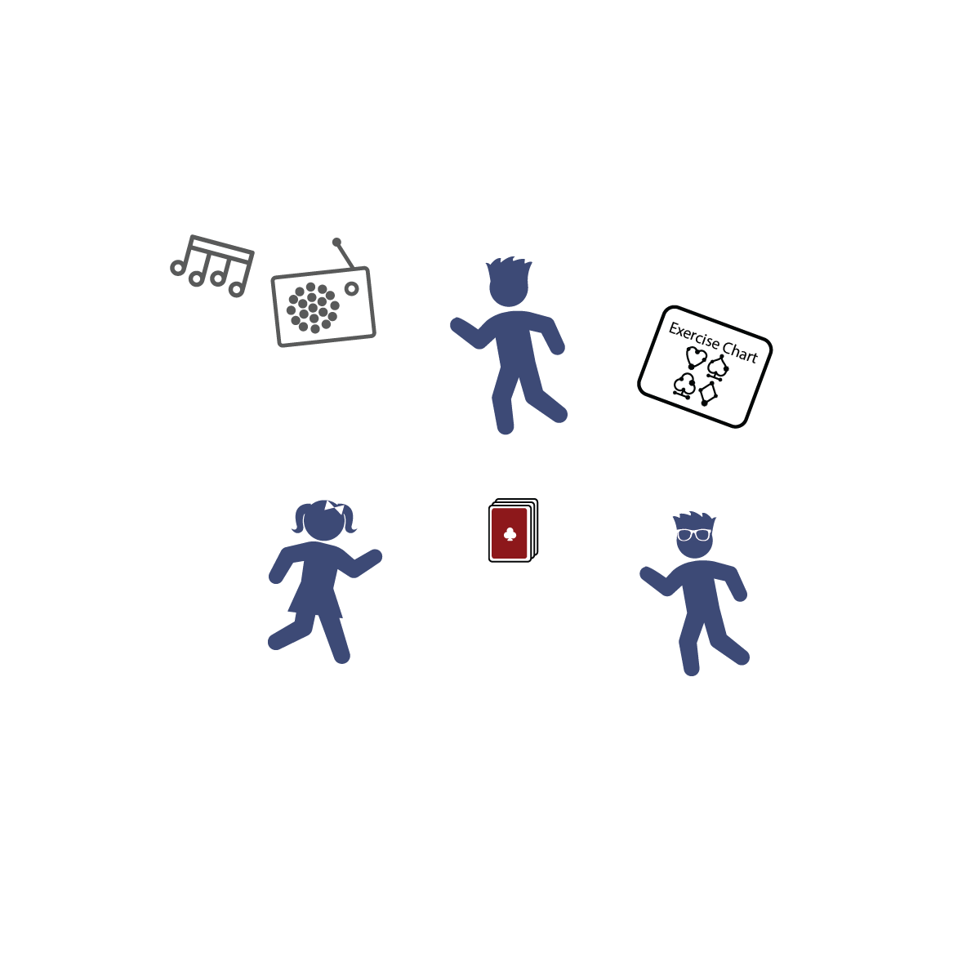

**Activity Procedures:**

1. Today’s friendly competition is Deck of Fitness. The object of the game is to do as many repetitions as you can of each exercise.
2. When you draw a card, you’ll use the exercise chart to determine which exercise to do. Complete the number of repetitions shown on your card. For example, if you draw the 4 of hearts, perform 4 jumping jacks.
3. Face cards (e.g., a king) are worth 10 repetitions. Aces are worth 11 repetitions.
4. In round 1, you and your friends will play together and select 1 card for everyone to perform. In round 2, you can compete: Everyone will choose their own card and complete their own repetitions/exercises.

**Tips:**

* Make sure you pace your activity safely. Don’t give up form for the sake of speed.
* Be sure you have enough activity space for safe movement.
* Follow this format, or create your own:
  + Hearts = Jumping Jacks
  + Clubs = Push-Ups
  + Diamonds = Invisible Jump Rope Jumps
  + Spades = Squats

**Equipment:**

* 1 deck of cards
* Fun music and music player

**Set-Up:**

1. Shuffle and place the deck of cards face down where everyone can reach it.
2. Create an exercise chart using the list shown under the “Tips” section below. (It’s okay to modify your chart using different exercises.)

* Use Proper Form
* Pace Your Movement
* Have Fun!
* **Hydration Station:** Be sure to stay hydrated before, during, and after exercising. Water has zero calories and is the best way to stay hydrated!
* I will perform exercises with perfect form and at a safe speed.