January Staff Recognition - Laurelville Elementary 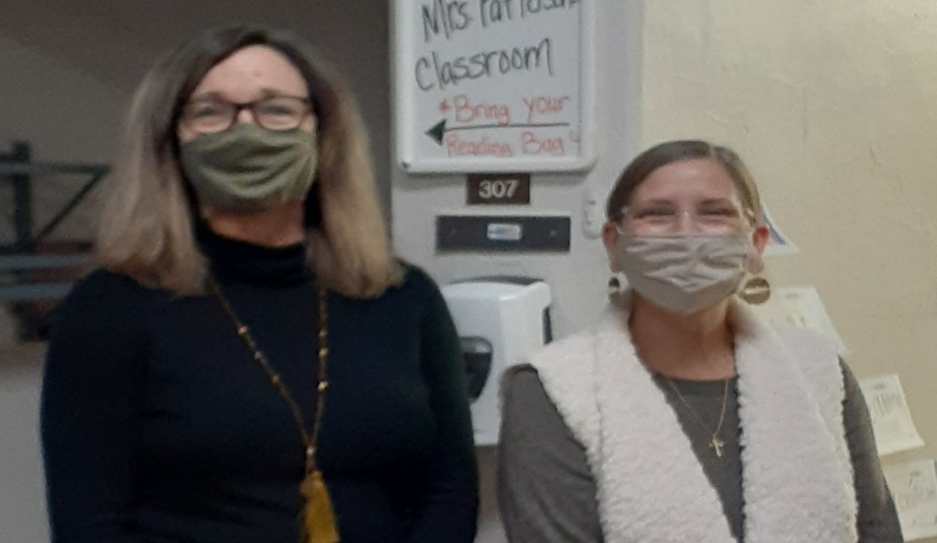
4th Grade Teachers: Mrs. Heidi Woods and Mrs. Belinda Wolfe
4th Grade Intervention Specialist: Mrs. Amanda Patterson
Laurelville Elementary would like to recognize the hard work that our 4th grade teachers and Intervention Specialist do on a daily basis! They assist our students in their daily academic learning, social-emotional learning and encouraging the needed skills to be outstanding student role models for their school building. These staff members also demonstrate dedication in preparing our 4th graders for their upcoming transition to Saltcreek Intermediate. They have worked extra hard this year to provide as much consistency and support to their students as possible through the transitions of online learning and in-person learning. Please encourage the student(s) in your home to give a HUGE “thank you” to these very important staff members to let them know how much we appreciate their daily efforts.
January Staff Recognition - Laurelville Elementary 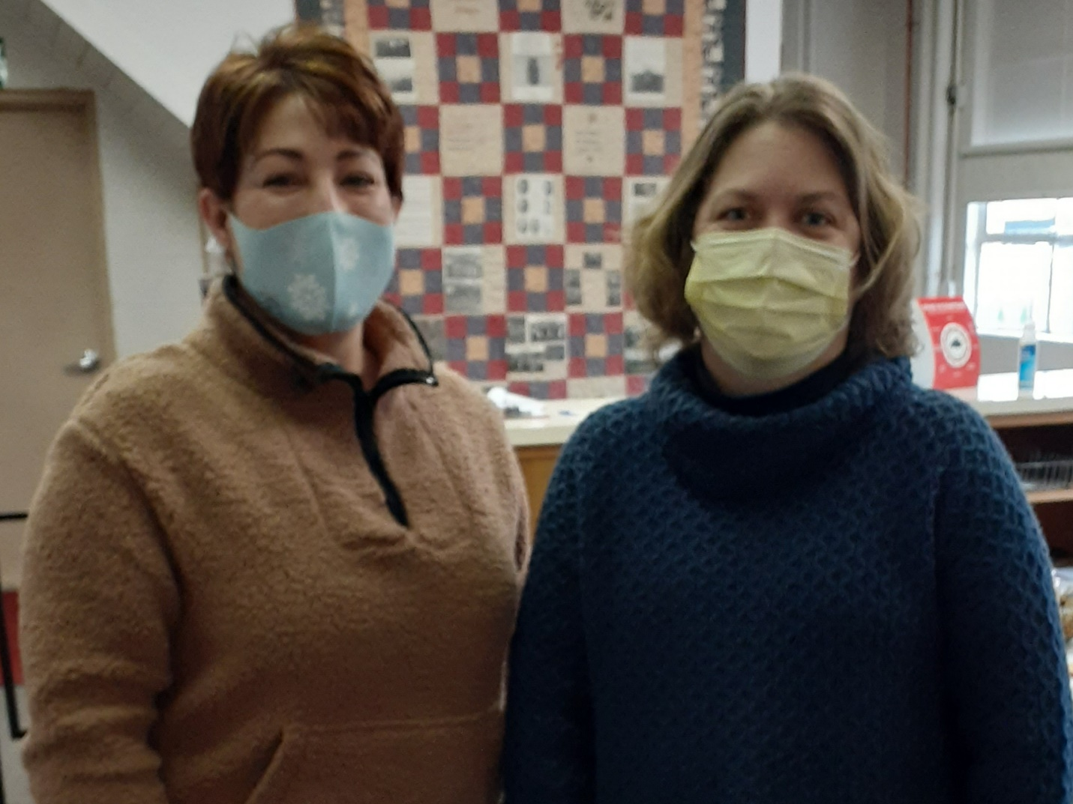
Mrs. Tami Clark (Principal) and Ms. Angie Stump (Administrative Assistant)
Laurelville Elementary would like to recognize the leadership that our Principal and Administrative Assistant model on a daily basis! They are dedicated to supporting our students, the guardians of our students and our school staff. These staff members keep our school day running smoothly with all of the hard work that we physically see them doing as well as the many tasks that occur behind the scenes that are a necessary part of having a successful school building. They have worked extra hard this year to assist us with staying organized, focused and supported throughout the many changes we have experienced. Please encourage the student(s) in your home to give a HUGE “thank you” to these very important staff members who demonstrate strong leadership skills to let them know how much we appreciate their daily efforts.

