the Tabletop training series  - 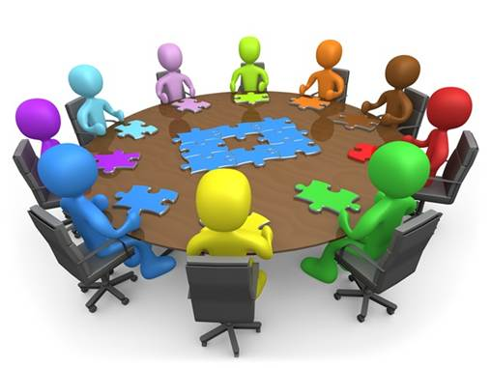  A service provided by Safety and Risk Management  If finding time for emergency response training is a challenge,  let us help you. We can provide training to fit into your regularly scheduled staff or safety team meetings.  Scenarios lasting from 5 minutes to 30 minutes can help test your emergency plans in an informal, low-stress environment. A great way to clarify roles and responsibilities and identify preparedness needs. Tabletop exercises will result in continued improvement of your threat assessment, crisis intervention, violence prevention and emergency response.  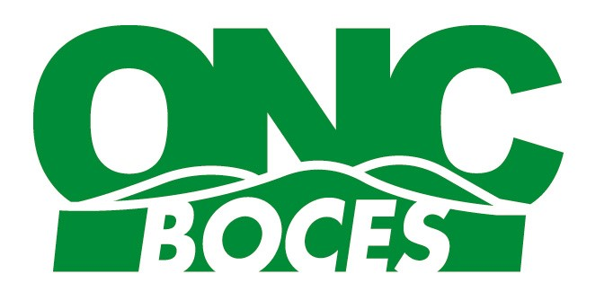  SRM Safety and Risk Management | Facilitate group discussion in a low stress environment  ____  Challenge your staff even when training time is limited  ____  Violence  Mental Health  Security  Bullying  Reunification  Etc.  ____  A starting point to live drills or full exercises  ____  To schedule training or get more information Please contact us at  607-286-7715 ext. 2606  Program Coordinator  Josh Reiss  jreiss@oncboces.org  Keyboard Specialist  Carrie Conklin  cconklin@oncboces.org  1914 County Route 35  Milford, NY 13807

